

Attention all secondary school athletic trainers! Have you been mapped? Help The University of Connecticut’s Korey Stringer Institute and the NATA by confirming your athletic training services. All that is needed of you is the completion a ten-minute survey. If you have not done so already the survey is available [here](https://uconn.co1.qualtrics.com/jfe/form/SV_enPMxrKzIqlYRnL). You can also check your current status by clicking here.

**The Benchmark Study**:

Funded by the NATA the Korey Stringer Institute managed to develop a benchmark study, which consisted of calling every single secondary school in the country. Public and private schools both were called in an attempt to collect some data on the status of the schools athletic training employment, number of athletes, number of students, sports at the school, sports covered at the school by the athletic trainer, and whether the athletic trainer was full time or part time.

**Mapping of the ATLAS project:**

ATLAS maps athletic trainers using an online program called Zeemaps by Zee Source. Zeemaps allows the mapping of schools by using the schools zip code, which is provided by the athletic trainers in the survey or has been provided in the benchmark study. When viewing a specific school in Zeemaps, school information and information about the status of the schools athletic trainer is noted. An example of the information provided as well as a sample Zeemap is displayed below.

Zeemap of Massachusetts

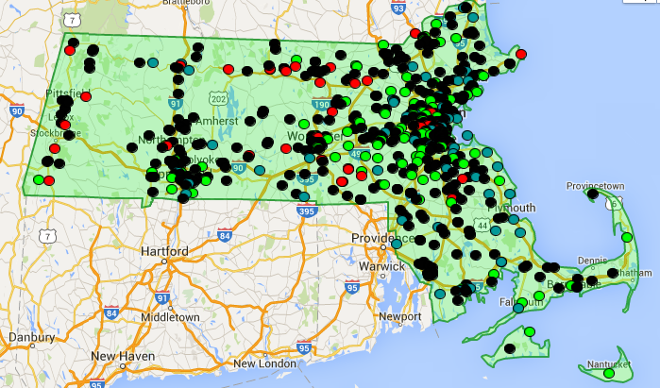

Sample Zeemap Information

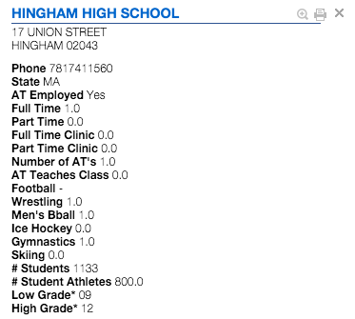

**The Intention of ATLAS**:

ATLAS plans to serve as a valuable resource to each state’s athletic training association. This data can be used to assist with legislative efforts and hiring of athletic trainers. Based on some of the questions we ask in the survey, we can tell whether or not Athletic Trainers are practicing emergency action plans, if they have their standing orders signed by a physician, and even improve communication following a concussion between two high schools athletic trainers that may not know each other.

**Where ATLAS is going:**

The Korey Stringer Institute of the University of Connecticut hopes to turn the ATLAS project into a real time resource for all secondary school athletic trainers. KSI is working towards making available the ability to readily access ATLAS and use it to communicate and legislate for more full time positions. On the research side of things we hope to figure out what factors result in an athletic trainer being hired full time in one district over another district whether it be socioeconomic, geographic, or even population density based by using accessible national education statistics data.

**How you can help the ATLAS project:**

If you are a secondary school athletic trainer, KSI asks that you check your state map (KSI.uconn.edu). Help the NATA SSATC and KSI update your information by completing the survey (5-10 minutes) and your marker will be updated for your school. Please allow 3-5 days upon completion for map to be updated.

